Oregon RIMS Signature Event 2022

2022 Winter Party at Topgolf

Oregon RIMS is hosting a Winter Party at Topgolf! If you have never been there, now is your chance. Topgolf is a golf themed venue that connects technology with sports entertainment. It is more than a driving range. It is an actual enhancement to your golfing experience without having to leave the clubhouse. Golf clubs and everything you need is provided. You do not need to be a professional golfer at Topgolf, everyone from beginners to scratch golfers will have fun.

We hope you will join us for an evening of networking, food and TOPGOLF. Come-out and see your friends and colleagues for some in-person fun in a heated, covered, mostly outdoor setting. Space is limited so be sure to RSVP early.

Date: | Thursday, January 20, 2022
Time: | 5:30PM to 8:30pm
Location: | Top Golf - Hillsboro  5505 NE Huffman Street, Hillsboro, OR 97124
RSVP/PayPal Link:  Cost: | https://oregonrims.org/  RIMS Members: $15  RRP/Students: $10  Non-Members: $25

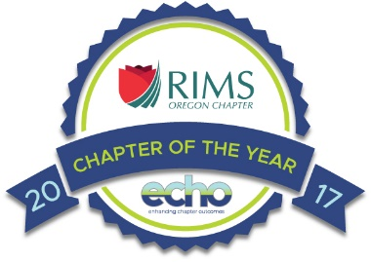
Please RSVP by Friday, January 17, 2022. Payment in advance via the PayPal links through the registration page on the OR RIMS Website is most appreciated. Attendees who do not RSVP will be charged $35 at the door.

